Pre-Training Basics

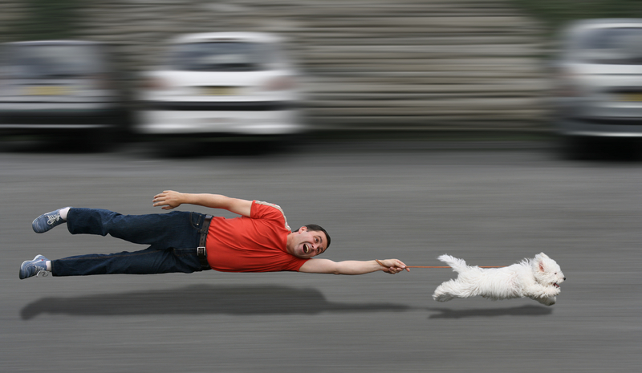

If you have a young puppy, we recommend that you wait until he’s at least 8 weeks old to begin formal training.
Before you begin the formal training lessons with a dog of any age, please plan to follow these keys to success:
- Be patient. Each dog is unique, and can only learn at his own pace. Some dogs learn quickly; others take more time. Patience is indeed a virtue when it comes to effective dog training!
- Be kind. This goes hand-in-paw with “Be patient.” Don’t lose your temper if your dog doesn’t “get it” right away, or appears to be ignoring you. Please do not punish your dog for not learning quickly enough. As a matter of fact, don’t punish your dog at all. (We’ll be teaching you effective ways to stop or prevent inappropriate behavior—without punishment.)
- Be flexible. If your dog is struggling to learn, be willing to change your training routine. The location may be too distracting. The time of day may be too close (or far from) feeding time. The length of your training session may be too long (or too short). The training exercises may need to be broken down into smaller, simpler steps. Remember, each dog is unique. Be flexible and willing to do whatever you can to help your dog succeed.
- Be generous. Be generous with your rewards and your time. Always reward your dog’s correct responses generously. Don’t be stingy with the treats—he’s worked hard and deserves a generous reward! And commit ample time to your training lessons. We’re all busy these days, but this is “quality time” for you and your dog. You’ll both enjoy and benefit from the lessons, so make sure your schedule is adjusted accordingly!
Rewards
One of the biggest keys to success with positive reinforcement training is rewarding your dog properly. This means giving him something he loves at exactly the right moment.
Your first task is to figure out what kind of reward will best motivate your dog.
Food Treats
All dogs are unique individuals. Most dogs are motivated by food that tastes and smells good to them. Food treats can be very small, which is handy for keeping them in your pocket or a pouch to use during training—and important to maintaining your dog’s caloric intake to healthy levels. So that’s the form of reward we’ll be using throughout this training.
Be sure what you’re giving your dog is good for him. But don’t rely on the packing of store-bought treats to tell you “Your dog will love it!” Strong-smelling meat and cheese treats are usually winners, but many store-bought treats are made primarily of other ingredients. Your dog may not appreciate artificial colors, tastes or smells.
Small morsels of cooked chicken are a popular home-made treat. But keep in mind that what motivates other dogs may not motivate yours. Experiment and find out what he loves to eat.
Non-Edible Rewards
What if your dog isn’t motivated by food (rare, but a possibility)? You’ll have to find something else that motivates him. You may think a couple of pats on the head are a great reward, but your dog may not. He might not even like it (most dogs don’t)! Try scratching his belly or some other form of petting. Again, experiment to find out what your dog loves.
Another form of reward to consider is play. Tossing a ball, playing tug-of-war, or playfully chasing your dog for a few minutes may be his idea of heaven.
The Best Reward
Let your dog show you what he truly loves. He’ll do this with his reaction to the reward you offer. You just need to pay attention to how he responds. Just because he accepts a piece of kibble doesn’t necessarily mean he loves it. Watch him carefully when you’re giving him a treat, petting, or playing with him. If he looks away or walks away, he probably isn’t all that thrilled about what you’re offering. But if he gets excited, stays close and begs for more, he’s showing you that he loves it and will be willing to work for that reward in the future.
For initial training, we highly recommend using a food treat as the reward. It’s the easiest to work with and gets the fastest results…just make sure your dog really likes it!
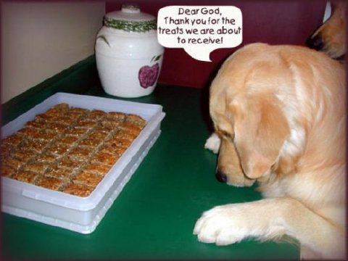
Photo Credit: http://www.flickr.com/photos/suzanneandsimon/
Timing
After you figure out the form of reward, the second key to positive reinforcement is timing. This is critical during early training: you must give the reward immediately after your dog performs the correct action. This means within half-a-second! Your response to his correct action must be clear and it must be instant. If you pause in stunned amazement that he actually did something right, then snap out of it and give him a treat several seconds later, you’ve blown it. You must train yourself to deliver instant gratification to your dog. Do this consistently, and you’ll be amazed at how quickly your dog learns.
Here’s another important tip about timing: don’t make your training lessons too long. Like humans, dogs can become bored by repetition. Bored students don’t learn very well. So to keep the training sessions effective, don’t make them outlast your dog’s attention span. Each dog is different, so you’ll need to be alert and notice when his attention starts wandering. Try for a 10-minute session and see how that goes. Shorten it if necessary. Don’t lengthen it to more than 15 minutes. Repeating a short session two or three times a day will be much more effective than having one long session each day.
Primary and Secondary Reinforcements
The instant reward you and your dog choose will be your primary reinforcer. A primary reinforcer is something your dog inherently loves. In other words, he was born loving it (treats, tummy rubs).
Another form of reward is known as a secondary reinforcer. A secondary reinforcer is something your dog must learn to love and be motivated by. Praise is an excellent example. Puppies are not born loving a phrase such as “Good girl!” After all, it’s just noise to them. They must learn to associate that noise with love.
A popular form of secondary reinforcement is clicker training. A clicker is a handheld device that makes a distinctive clicking sound. That sound is basically a substitute for verbal praise. When used properly, your dog will learn to associate the clicking sound with love. We prefer using verbal praise versus a clicker, simply because your voice is something you’ll always have with you. If you prefer to use a clicker, just remember to mentally substitute “click” when the lessons say verbal praise or “Good!”
Consistency is Key
Regardless of whether you use your voice or a clicker, the most effective way to train your dog is to use a combination of primary and secondary reinforcers that are consistent.
If you’ll use your voice instead of a clicker, choose a phrase and use it exactly and consistently. Dogs are not people, remember? Words are just noise to them. They have no idea that “Good girl,” “Great job,” “Way to go Molly” or other phrases all mean they did the right thing. Pick your praise phrase, and make sure you (and others in your family) use that exact phrase or word every single time.
Then, several times a day, say your praise word or phrase and immediately give your dog the primary reinforcer (such as the treat you know he loves).
Do about five repetitions, two or three times a day, for two days. You can also use your praise word or phrase when rubbing her belly, when she’s eating his dinner, or any other time you’re sure she’s enjoying something she loves. Within a few days, she’ll learn to love the secondary reinforcer (the praise phrase or word) and will be eager to hear you say it.
(Throughout the training course we’ll use the example of “Good,” but substitute your own choice of secondary reinforcer. Remember to use it—and only it—consistently.)
During early training, the combination of the primary and secondary reinforcers will be extremely powerful and effective… more so than using either form of motivation alone.
Treats Won’t be Needed Forever
Don’t worry that you’ll have to carry treats around in your pocket all the time to get your dog to behave. As your dog learns, her obedience will eventually become habitual. You won’t need to consistently use treats or other primary reinforcers for those behaviors beyond that point. (You’ll need to use them consistently whenever teaching something new, though.) It will always be a good idea to continue using the secondary reinforcer (“Good!” or whatever). You’re basically thanking your dog for doing what you asked… simple common courtesy is always a good thing!
We’ll tell you when you can start decreasing the use of treats or other primary reinforcers. But for now, and whenever you’re teaching your dog something new, be sure to use both forms of positive reinforcements as instructed.
OK, now that you know the basics of rewards and timing, you’re ready to begin training your best friend!

